MINI MASTER PLAN PROJECT

TELKOM UNIVERSITY | School of Industrial Engineering| Project Management Profession Group

<PROJECT NAME>

2018

Submission Date : dd/mm/yy hour/minute/second

Advisor : Devi Pratami

Group : 2

Class : TI-40-05

|  |  |  |  |  |
| --- | --- | --- | --- | --- |
| Name | Student ID | Role | Task Proportion | Photo |
| Dilan | 112050987 | Project Manager | 40% |  |
| Milea | 112050101 | Project Team | 20% |  |
| Anhar | 112050980 | Project Team | 20% |  |
| Pidi Baiq | 112058702 | Project Team | 20% |  |

1. Business Case

(**Project Definition)**

Generally defines the idea of your project based on specific topic and the preferred area of interest, and source of project

**(Project Objective)**

Explains the specific and detailed objectives of the project using the SMART rule (Specific, Measurable, Agreed upon, Realistic, Time-bound)

1. Statement of work
   1. Product scope
   2. Project scope
   3. Acceptance Criteria
   4. Assumption
   5. High level risk
   6. Constraints
   7. Milestone Project
   8. Project exclusion
2. Stakeholder Register

|  |  |  |  |  |  |  |
| --- | --- | --- | --- | --- | --- | --- |
| No | Name | Project Role | Stakeholder Impact | Company | Main expectation | Attitude about the project |
| 1 | A |  |  |  |  |  |
| 2 | B |  |  |  |  |  |
| 3 | C |  |  |  |  |  |
| 4 | D |  |  |  |  |  |
| 5 | E |  |  |  |  |  |

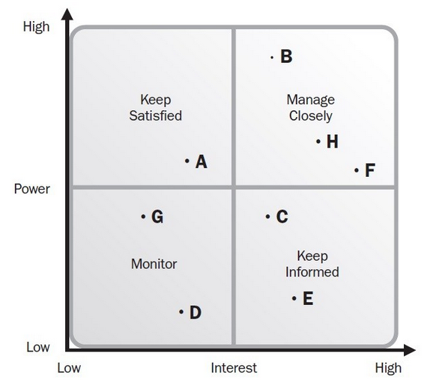

|  |  |  |  |  |  |  |  |
| --- | --- | --- | --- | --- | --- | --- | --- |
| No | Name | Project Role | Power | Interest | Category | Stakeholder engagement | Treatment/  major requirement |
| 1 | A |  |  |  |  |  |  |
| 2 | B |  |  |  |  |  |  |
| 3 | C |  |  |  |  |  |  |
| 4 | D |  |  |  |  |  |  |
| 5 | E |  |  |  |  |  |  |
| 6 | F |  |  |  |  |  |  |

4. Organizational Chart

5. Work Breakdown structure

6. Activity list

|  |  |  |  |  |  |  |
| --- | --- | --- | --- | --- | --- | --- |
| No | Work Package | Activity | Predecessor | Duration | cost | Human Resource |
| 1 |  |  |  |  |  |  |
| 2 |  |  |  |  |  |  |
| 3 |  |  |  |  |  |  |

RACI CHART

|  |  |  |  |  |  |  |
| --- | --- | --- | --- | --- | --- | --- |
| No | Work Package | Activity | Stakeholder A | Stakeholder A | Stakeholder A | Stakeholder A |
| 1 |  |  |  |  |  |  |
| 2 |  |  |  |  |  |  |
| 3 |  |  |  |  |  |  |

7. Project Schedule

7.1 Gantt Chart

Example:

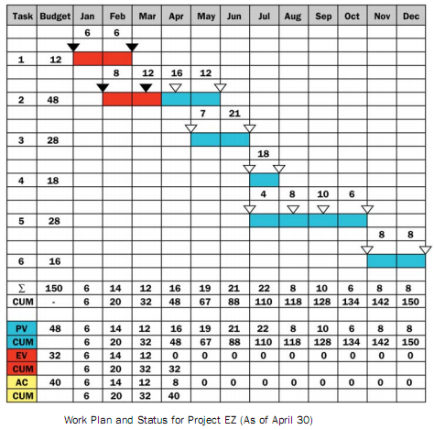

7.2 Network Diagram

Example:



8. Project Cost

8.1 Project Budget

Example:

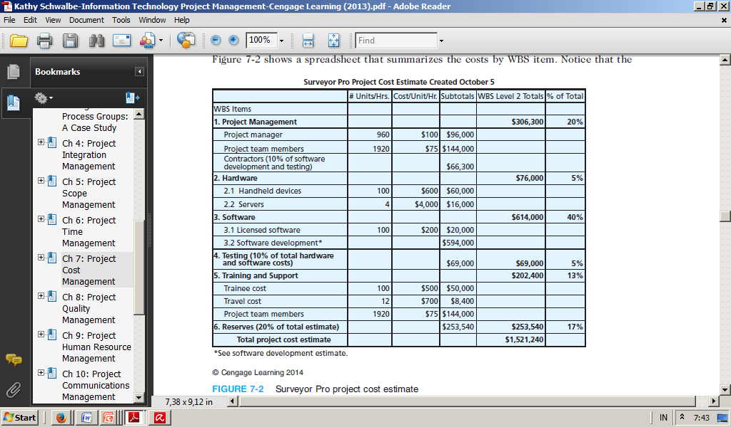

8.2 Funding Limit Requirement

Example:

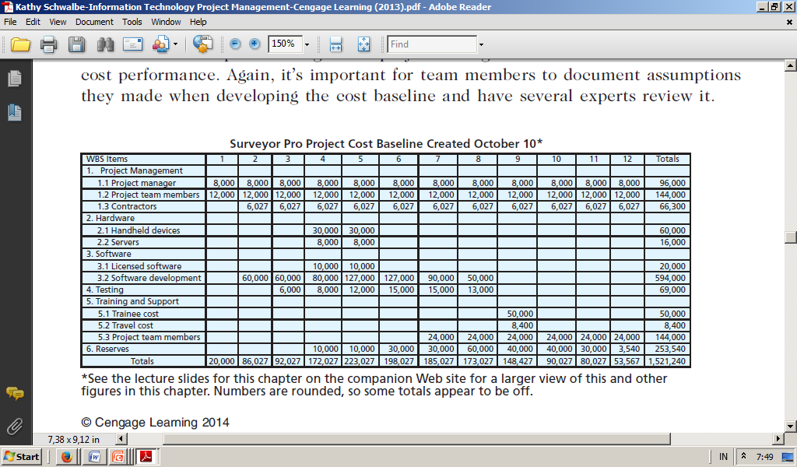

8.3 Project S-Curve

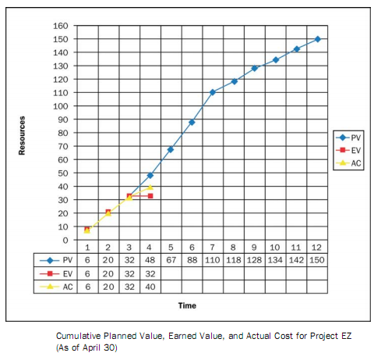

9. Quality Metric

|  |  |  |  |
| --- | --- | --- | --- |
| No | Activity | Possible error | Treatment |
| 1 |  |  |  |
| 2 |  |  |  |
| 3 |  |  |  |

10. Resource Requirement

|  |  |  |  |  |
| --- | --- | --- | --- | --- |
| WBS | Activity/  Tasks | Skills Required | Experience and/or  Degrees Required | Another Resource requirement |
|  |  |  |  |  |
|  |  |  |  |  |
|  |  |  |  |  |

11. Risk Assessment

11.1 List of Risk

|  |  |  |  |
| --- | --- | --- | --- |
| No | Risk Category* | Risk | Secondary Risk |
| 1 |  |  |  |
| 2 |  |  |  |
| 3 |  |  |  |

*External: EEF, regulatory, market shift

Internal: inexperience tem, staffing, issues, changes to schedule, scope, equipment, material

Technical: changes in technology, technical process

Commercial: customer stability, terms and cond within contract vendor

Unforeseeable: small portion of risk, only 10 %

10.2 Qualitative Analysis

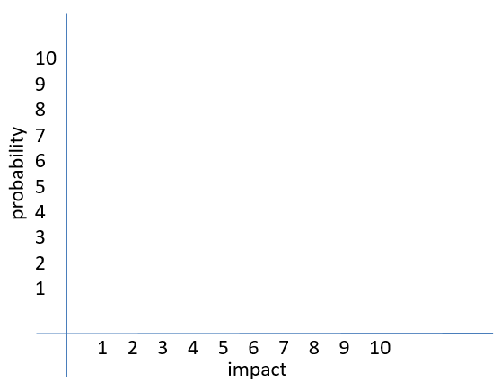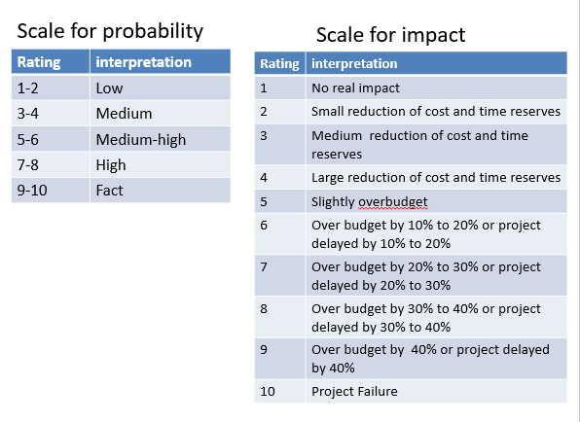

10.3 Risk Register

|  |  |  |  |  |  |  |  |  |
| --- | --- | --- | --- | --- | --- | --- | --- | --- |
| No | Risk category | Risk | Probability | Impact | Total | *Risk parameter | Risk Owner | Risk Response |
| 1 |  |  |  |  |  |  |  |  |
| 2 |  |  |  |  |  |  |  |  |
| 3 |  |  |  |  |  |  |  |  |

11. Communication Management Plan

Example:

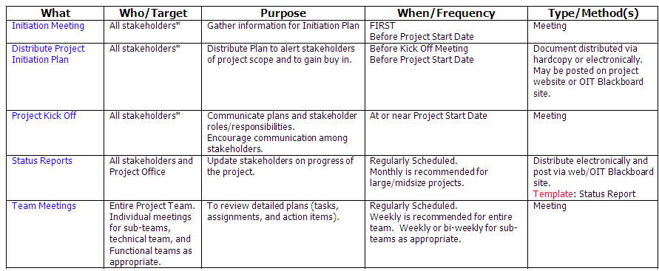

References

(example)

1. G. Eason, B. Noble, and I.N. Sneddon, “On certain integrals of Lipschitz-Hankel type involving products of Bessel functions,” Phil. Trans. Roy. Soc. London, vol. A247, pp. 529-551, April 1955. (*references*)
2. J. Clerk Maxwell, A Treatise on Electricity and Magnetism, 3rd ed., vol. 2. Oxford: Clarendon, 1892, pp.68-73.
3. I.S. Jacobs and C.P. Bean, “Fine particles, thin films and exchange anisotropy,” in Magnetism, vol. III, G.T. Rado and H. Suhl, Eds. New York: Academic, 1963, pp. 271-350.
4. K. Elissa, “Title of paper if known,” unpublished.
5. R. Nicole, “Title of paper with only first word capitalized,” J. Name Stand. Abbrev., in press.
6. Y. Yorozu, M. Hirano, K. Oka, and Y. Tagawa, “Electron spectroscopy studies on magneto-optical media and plastic substrate interface,” IEEE Transl. J. Magn. Japan, vol. 2, pp. 740-741, August 1987 [Digests 9th Annual Conf. Magnetics Japan, p. 301, 1982].
7. M. Young, The Technical Writer’s Handbook. Mill Valley, CA: University Science, 1989.